Unit Topic:/Title: The Mythological Stories of Ancient Greece Teacher: Alexandra Fleming
Grade Level: 6th –Social Studies

Timeframe: 5-7 days

Brain Target #1
Emotional Connection:
 For a personal connection to the content, students will choose a major character from Greek mythology; they will complete activities that require them to identify with the character throughout the unit.

 Students will keep a daily journal to record their thoughts and feelings from the point of view of the character; the entries will help them to view concepts taught during the unit through the lens of their selected character.

 Students will develop personal connections with classmates through the activities that require them to work in pairs to share legends and myths that their characters have in common.

 The teacher will use movement, visual arts, and drama to create an interactive and positive learning environment.

 Students will be offered choices in their learning goals and activities.

- The teacher will establish and maintain classroom routines such as:
  - Greeting students at the door and providing a new Greek symbol, vocabulary, or greeting as students enter.
  - Liberally using behavior-specific praise throughout the unit.
  - Rewarding each group of students for appropriate collaborative activities.
  - Providing culminating celebration at the completion of the unit based on attaining work and behavioral standards.

Brain Target #2
Physical Environment:
 Change the physical environment in the classroom to fit the structure of various thematic activities; e.g. staging area for students to introduce themselves as their character to the class.

 Display poster and pictures of Greek life and activities around the room to create the atmosphere of ancient Greece.

 Display exemplary student work as it is completed.

 Play Greek music at the beginning of class to set the mood.

 Involve students in the care and order of classroom space.

Brain Target #3
Introductory “Big Picture” Activity/Assessment of Prior Knowledge
Concept Map / Advanced Organizer:

Click here to view concept map

Social Studies Content Standards
 Describe major cultural achievements of Greek civilization such as art, science, political systems, and philosophy

Language Arts Content Standards
 Vocabulary - Use new vocabulary in speaking and writing to gain and extend content knowledge and clarify expression
 Reading – Develop and apply comprehension skills through exposure to a variety of texts.
- Explain relationships between and among text (i.e. cause and effect, sequence).
- Synthesize ideas from text to form new understanding
 Writing – Write a variety of forms for personal expression (i.e. descriptions such as character sketch, journaling, skits).
 Drama – Analyze elements of drama to facilitate understanding.

 Technology Standards—Use the internet for content research.

Learning Goal:
Students will know the themes of Greek mythology/religion by studying characteristics of Greek deities and immortals.

Brain Target #4
Activities for Teaching Mastery of Content, Skills, and Concepts

 Objective: Students will know characteristics of the various deities/immortals that comprise Greek religion and be able to choose a character based on their own knowledge and interest for further in-depth study.
--Activity: Students read selections of the textbook and selected resources. They will take notes using a T-chart. (Click here for example of a T-chart.)
--Activity: Students will use online sources to find pictures and descriptions of three deities/immortals. They will compare characteristics of the three using a Venn diagram. (Click here for example of a Venn diagram.)
--Activity: Students will write a brief “autobiographical” sketch that describes the one deity/immortal they have chosen for in-depth study. They will also write a Brief Constructed Response (BCR) (Click here for description of BCR.) that explains why they have chosen this character.

 Objective: Students will know the broad themes of Greek mythology (e.g. creation, reward and punishment, and nature) and be able to depict their chosen deity/immortal in terms of a particular theme.
--Activity: Students will draw a storyboard showing an event in the life of their chosen character that exemplifies one of the themes of Greek mythology.
--Activity: Students will prepare and deliver an oral presentation to classmates that describes 1) the characteristics and attributes of their chosen deity/immortal, the realm of control, and the place of their character in the hierarchy of Greek deities 2) the event described in the storyboard, and 3) the mythological theme depicted in the event.
--Activity: Students will choose a deity/immortal from one or more of the class presentations whom they believe shares a common theme with their own character. They will write a BCR to describe why the character depicts the same theme as their own.
--Activity: Within assigned pairs, students will write a dialog that describes a fictitious shared event that highlights the mythological theme.

Brain Target #5
Activities for The Application of Knowledge
The class will participate in traditional Greek festivals to understand the importance of mythology, religion, art, architecture, drama, and music, in the daily life of Greek citizens, slaves, women and children.

 Objective: Students will apply the themes of Greek mythology to contemporary stories and will be able to present them within the context of the Dionysian theatrical festival.
--Activity: Students will rewrite their storyboard/dialog to a contemporary setting that describes a modern-day event.
--Activity: Students will create masks and/or costumes that depict their characters and the importance of their character to Greek culture.
--Activity: Each pair will perform their dialog as a part of a class-wide theatrical festival using their masks, and other dramatic elements such as music, sets, costumes, etc. (click here to view student presentations)

Brain Target #6
Evaluating Learning

 Anchor papers are used to evaluate BCRs used for drills and lesson summaries. A 3-point rubric is used to assess the different components needed in a BCR. Peer evaluation based on rubric and anchor.

 Rubrics will be constructed for evaluation of storyboards, written dialogs, oral presentations of dialogs, festival presentations.

Materials:
Greek Music
Posters and Pictures of contemporary and historic Greek culture and society
Art materials for construction of masks
Related readings on Greek mythology

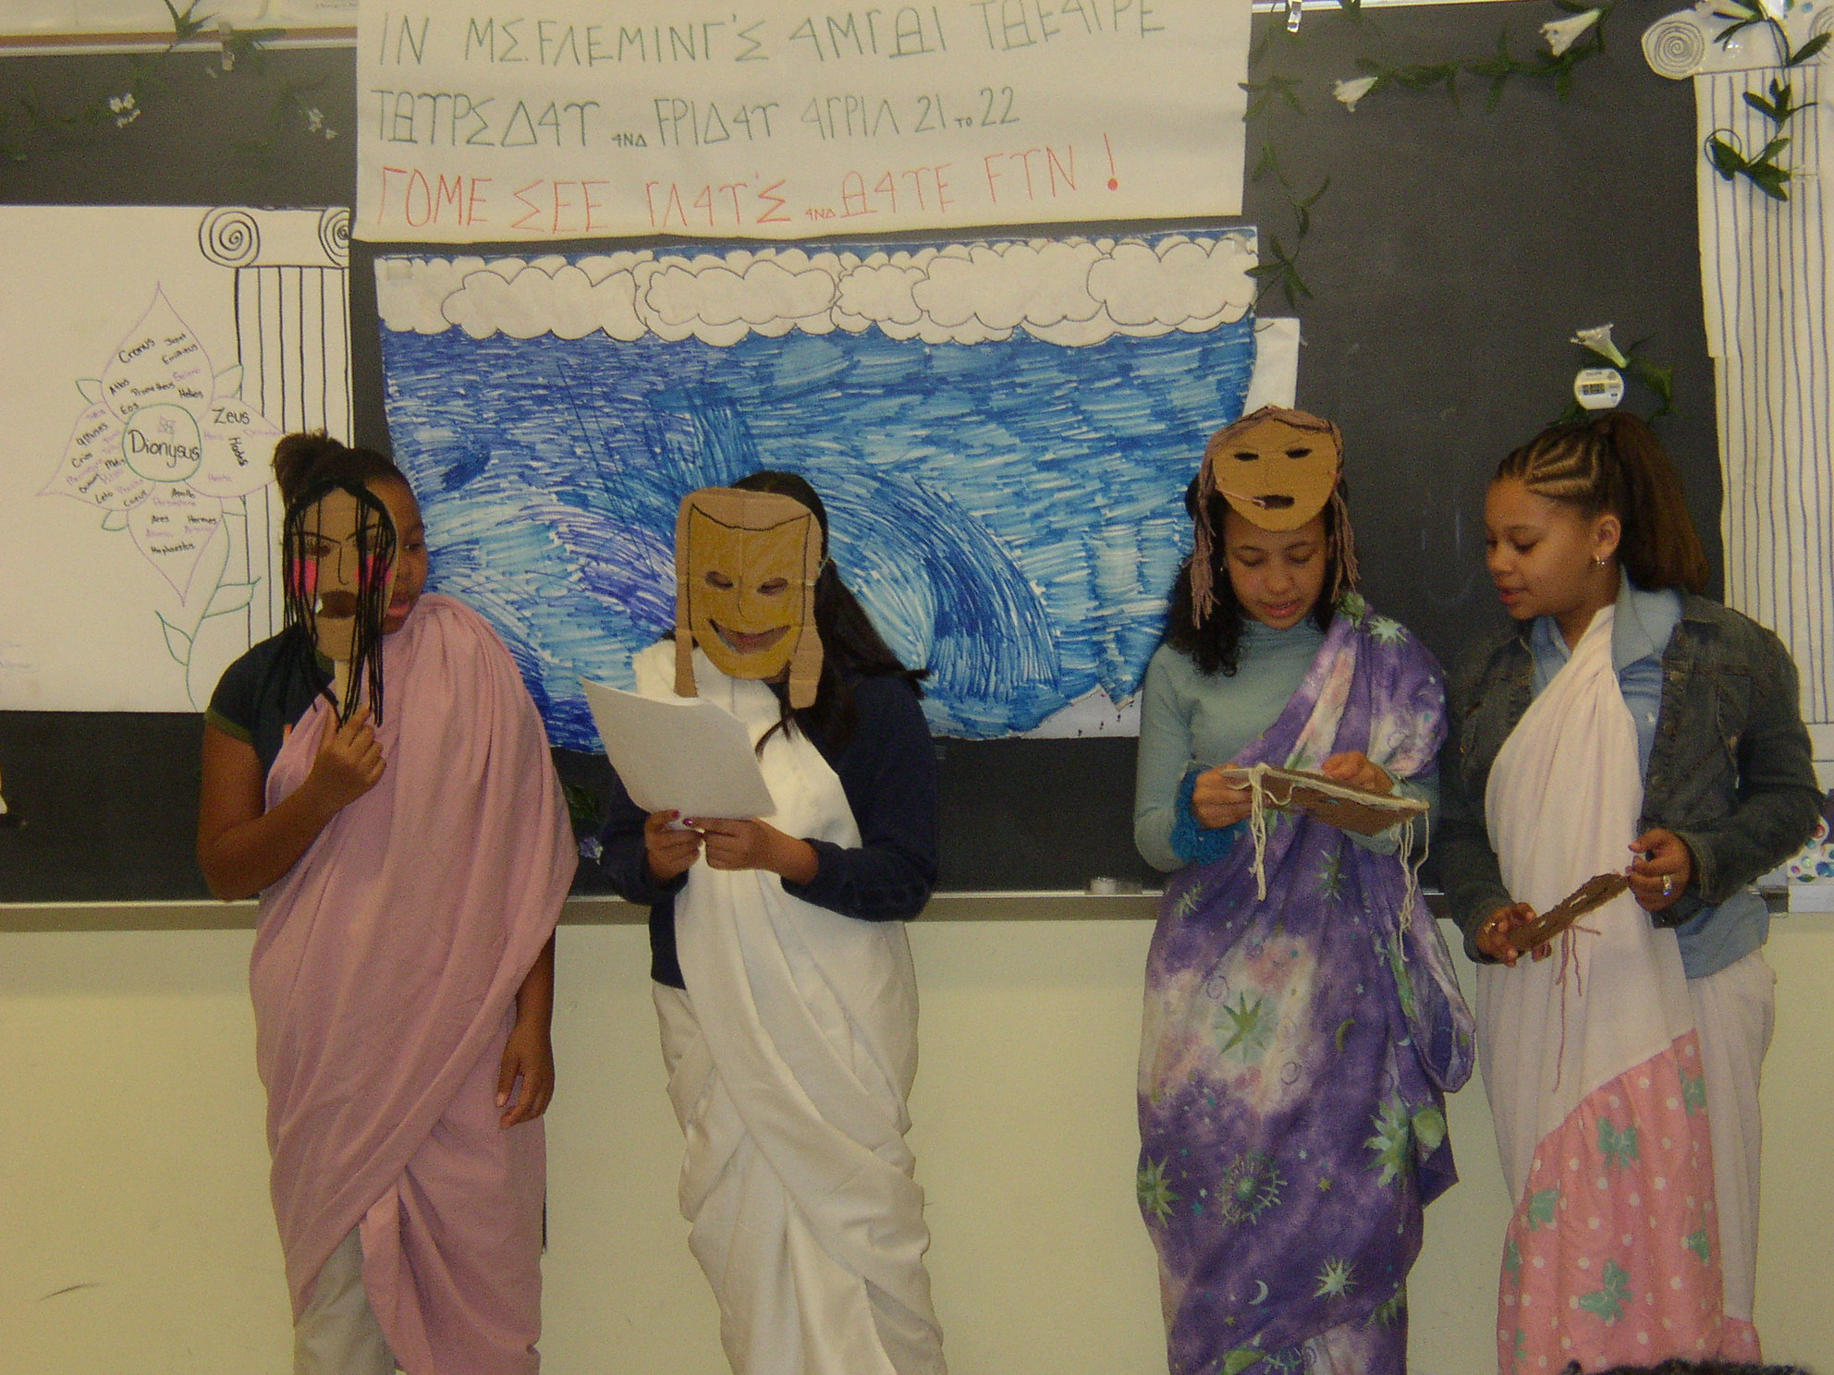

Students share their Greek mythological characters with classmates through dialogs, masks, and costumes.
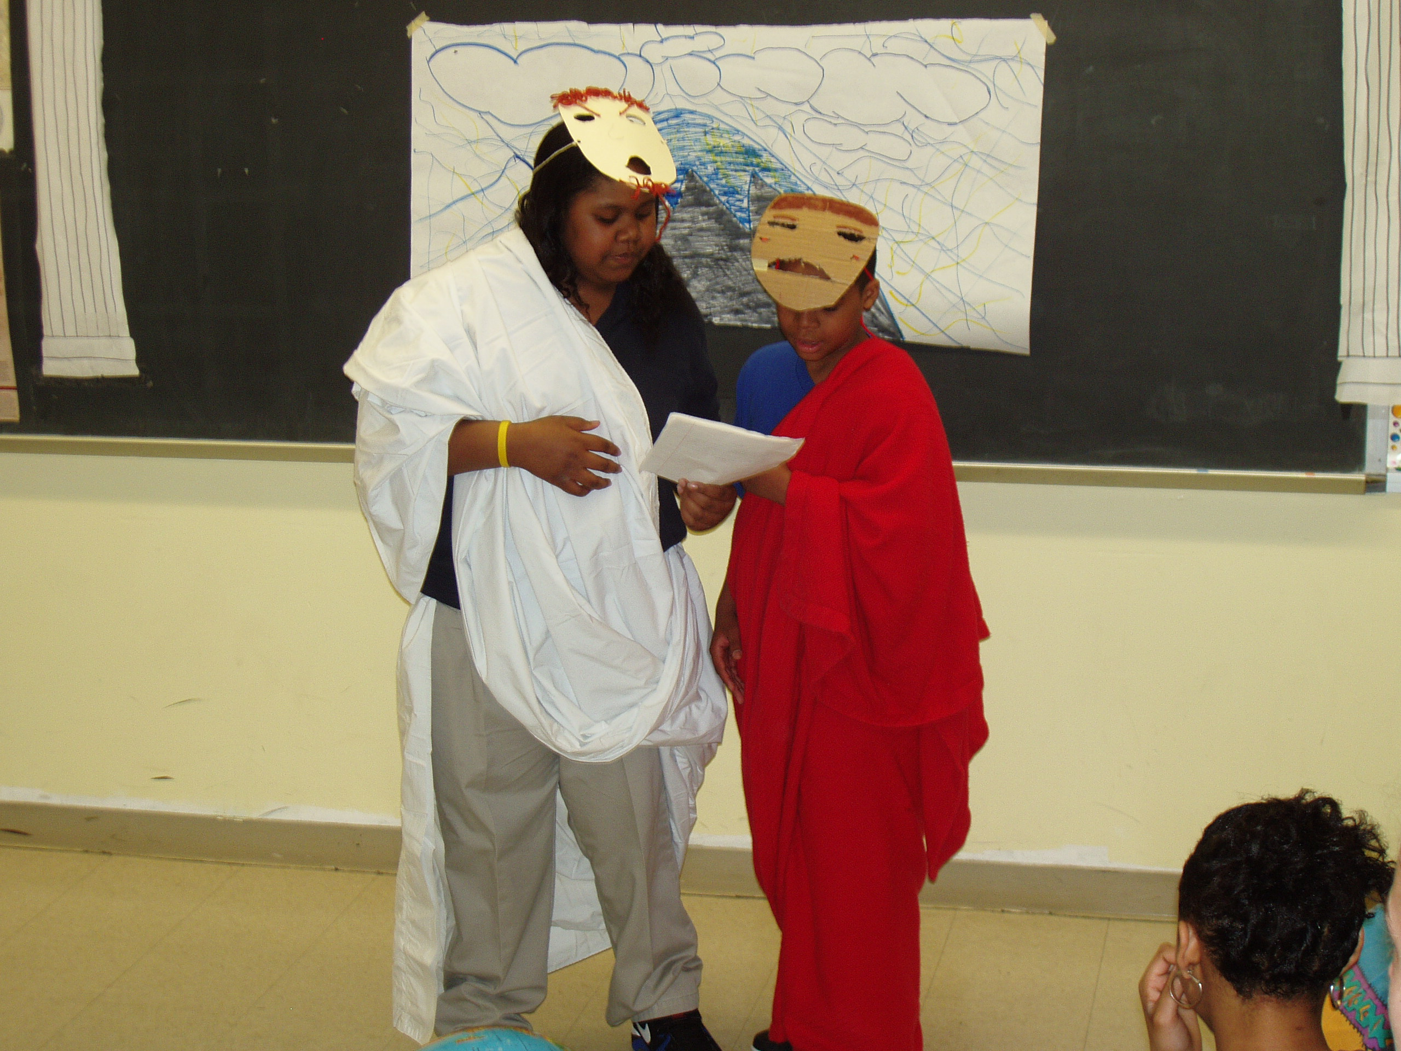

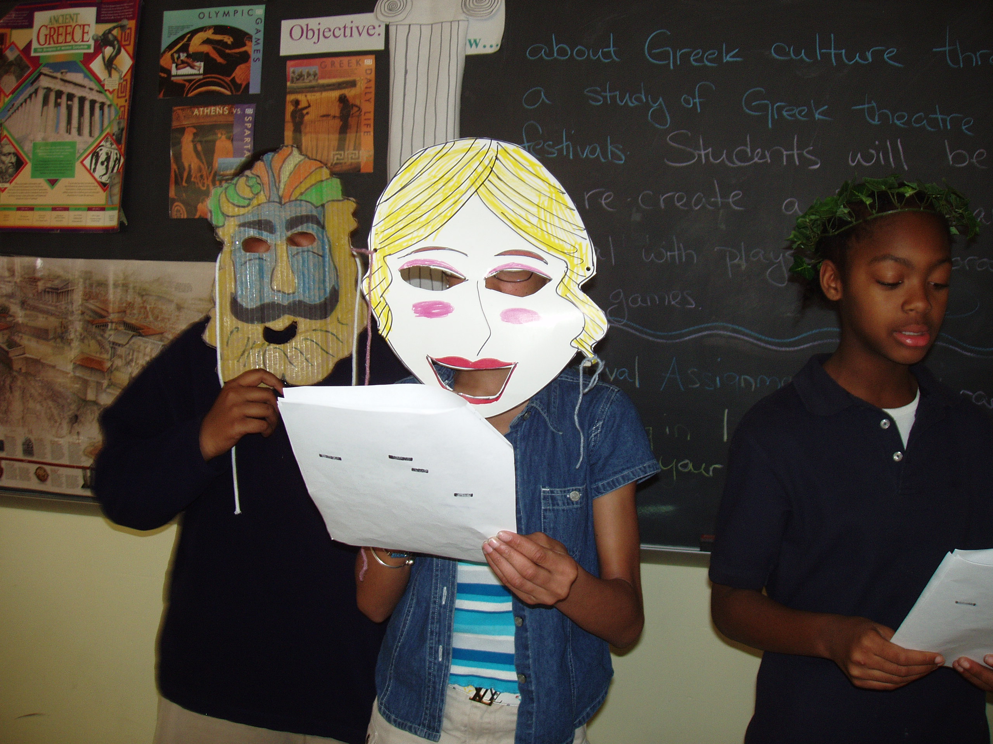

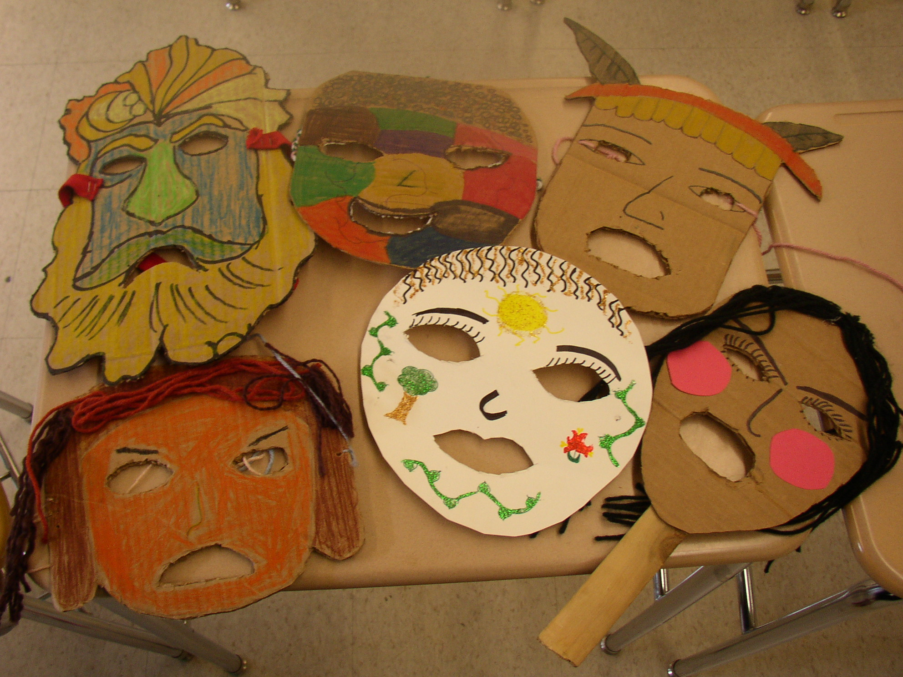

Masks constructed by students to depict Greek mythological character.

Concept Map of Overall Ancient Greece Unit

